Azure Fundamentals AZ900
  - Learning Documentation
Contents
Cloud Computing 3
Definition 3
Shared Responsibility Model 3
Types of Cloud Models 4
Benefits of using cloud services 5
High Availability 6
Scalability 6
Reliability 6
Governance and Security 6
Management of the cloud 6
Management in the cloud 6
Core architectural components of Azure 6
Azure physical infrastructure 6
Azure management infrastructure 8
Management Group 8
Azure RBAC 9
Azure virtual machines 9
Virtual machines availability sets 9
Azure containers 9
Azure Kubernetes Service 10
Azure Functions 10
Types of Azure App Services 11
Azure Virtual Networking 11
Azure virtual private networks 12
Difference between Route based VPN, BGP, ExpressRoute 12
Azure VPNs – High availability scenarios 13
ExpressRoute Global Reach 14
ExpressRoute connectivity models 14
Azure storage services 14

Cloud Computing

Definition
Cloud computing is the delivery of computing services over the internet. Computing services include common IT infrastructure such as virtual machines, storage, databases, and networking. Cloud services also expand the traditional IT offerings to include things like Internet of Things (IoT), machine learning (ML), and artificial intelligence (AI).
Cloud means internet, computing refers to doing computations. So together it means, doing computer-based operations like computing, networking, storage, virtual machines etc via internet

Shared Responsibility Model
Server Maintenance will be taken care by Azure People like Cooling, connectivity, security etc but data ingestion, data access and governance will be by consumer.
For a cloud SQL database, Azure will take care of DB maintenance and data ingestion by consumer
For a VM, whole maintenance by consumer since the deploy the VM from Azure, anything inside Azure will be taken care by consumer.
IaaS (Infrastructure as a Service) provides virtual machines and storage – eg: Virtual Machine
Eg use case: Lift-and-shift migration, Testing and development
PaaS (Platform as a Service) offers a platform for developing and deploying applications eg: Azure App Services
Eg use case: Development framework and Analytics or business intelligence
and SaaS (Software as a Service) delivers pre-built software applications PowerBI, Microsoft 365
- eg use case: Email and messaging.
- Business productivity applications.
- Finance and expense tracking.

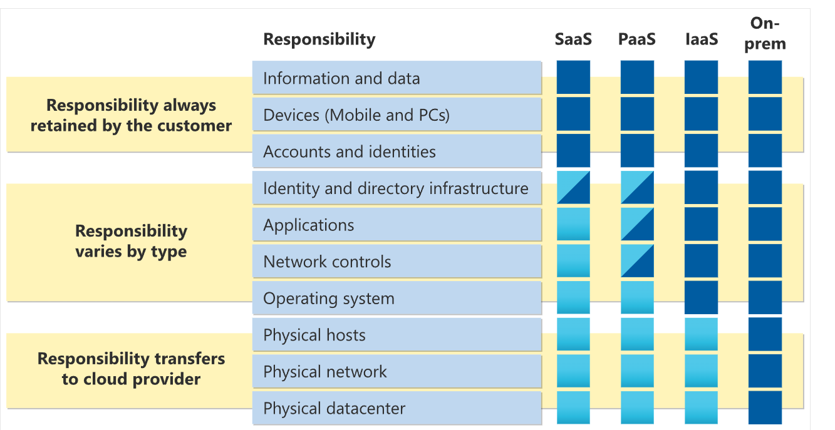

Types of Cloud Models
Private cloud: Could be companies own datacenter or exclusive azure’s datacenter not shared/collocated by other companies. Lot of security control by organization is feasible but expensive
Public Cloud: Shared by other companies, less security control, less expensive
Hybrid Cloud: Security control by organization is feasible, can choose a public cloud along with a private cloud, more flexible.
There are many ways to connect Private or On-Premises datacenter to Azure.
VPN Gateways – Uses ISP (Public internet service provider). Custom AD Partition is possible only here,
ExpressRouter – Customized FibreOptic internet only between those two end points. Highly securable and recommended.
Azure WAN – Connect the VPN/ExpressRouter by managing traffic between multiple branches of company to Azure. ExpressRouter or VPN is WAN
WAN = The Roads
- A WAN (Wide Area Network) is like the actual roads, highways, and bridges that physically connect cities (or in this case, your office and the Azure cloud).
- It’s the network connection itself.
- Example: Your office is connected to Azure via a VPN or ExpressRoute—that’s your WAN.

Microsoft Entra Connect through Microsoft AD DS. Active Directory Domain System. This is to access azure through on-premise. Not to give password each time (I guess)
ExpressRoute is for building a private network highway, while Azure Relay is for securing communication between specific applications across network boundaries.
Multi-cloud: Use different cloud providers with two or more public cloud.
Azure Arc: Azure Arc is a set of technologies that helps manage your cloud environment. Azure Arc can help manage your cloud environment, whether it's a public cloud solely on Azure, a private cloud in your datacenter, a hybrid configuration, or even a multi-cloud environment running on multiple cloud providers at once.
What it does:
- Connects your resources to Azure:
Azure Arc allows you to connect your on-premises servers, Kubernetes clusters, and other resources to the Azure Resource Manager (ARM).
- Provides a single view:
You can then manage, monitor, and govern all of these resources, including those outside Azure, from the Azure portal.

Azure VMware Solution: If you have VM-based private cloud and want to switch to public/hybrid, VMware solution helps with that
Consumption-based model : Pay as you go. This is Operational Expenditure where you spend only for operations whereas Captial Expenditure takes care of investing buy tangible resources like data center cooling system etc

Benefits of using cloud services
Load Balancing, High Availability and Auto Scaling, Predictability of Performance and Cost(Total Cost of Ownership (TCO) or Pricing Calculator to get an estimate of potential cloud spend), Reliable, security, governance and manageability

High Availability
It is based on uptime which varies based on cost. There is a difference between 99% and 99.9%

Scalability
This refers to increasing the capacity during heavy traffic/performance issues.
Vertical Scaling (Scale up/down) – Increase the RAM in CPU of a single machine
Horizontal Scaling (Scale out/in) – Increase the servers/nodes to share the workload
VS is cost effective but chances of failure is high as the data relies only in one machine and if that has to get patch updated, there will be downtime. But HS it quite opposite.
Refer this link for better understanding Horizontal vs Vertical Scaling

Reliability
Azure is reliable since resources are available in different locations and auto shifting is possible if one location datacenter goes down.

Governance and Security
Distributed denial of service (DDoS) is prevented by cloud providers. If you want more secured environment, go with IaaS to do your own patch updates.

Management of the cloud
Scale up/down in/out the resources when needed, deploy the resources and monitor it, set alerts about performance

Management in the cloud
Manage cloud through WebPortal, API, PowerShell and CLI

Core architectural components of Azure

Azure physical infrastructure
Region is asked for all the services except for Microsoft Entra ID, Azure Traffic Manager, and Azure DNS
An availability zone is set up to be an isolation boundary. If one zone goes down, the other continues working. Availability zones are connected through high-speed, private fiber-optic networks.
Availability zones are primarily for VMs, managed disks, load balancers, and SQL databases. Azure services that support availability zones fall into three categories:
- Zonal services: You pin the resource to a specific zone (for example, VMs, managed disks, IP addresses).
- Zone-redundant services: The platform replicates automatically across zones (for example, zone-redundant storage, SQL Database).
- Non-regional services: Services are always available from Azure geographies and are resilient to zone-wide outages as well as region-wide outages. Not specific to one region/zone. It is available across the globe. Eg: Microsoft Entra ID no region/zone will be asked for this.
Even with the additional resiliency that availability zones provide, it’s possible that an event could be so large that it impacts multiple availability zones in a single region. To provide even further resilience, Azure has Region Pairs.

One or Group of Datacentre forms Availability Zones -> Multiple availability zones -> Regions -> Two regions connected -> Region Pairs
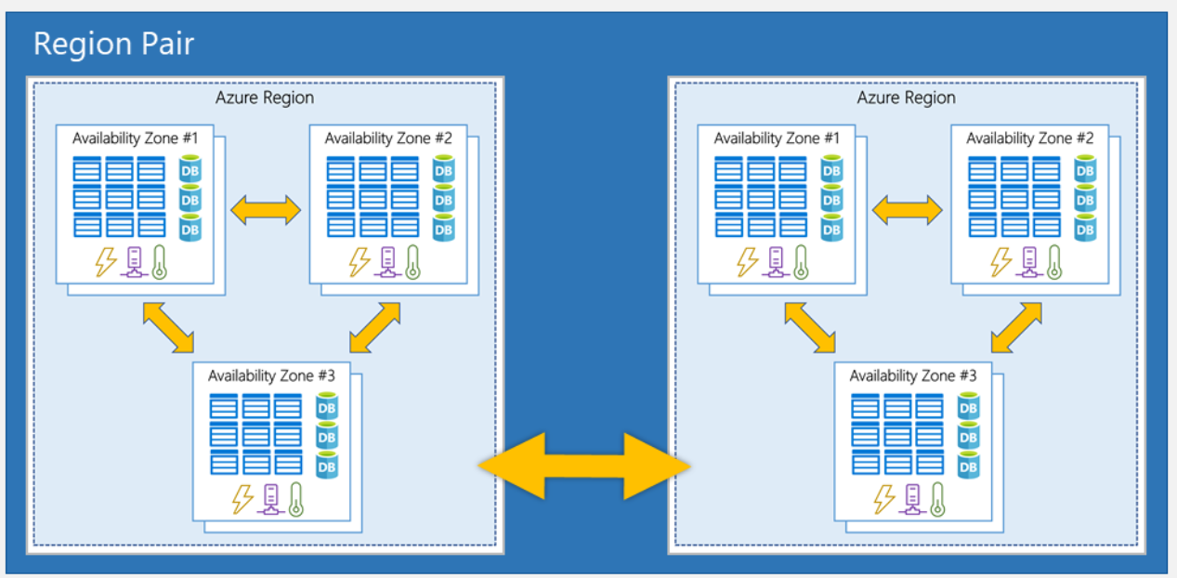

Region Pairs: East US region is paired with West US. So if one has outage or patch update, the other region will be restored and running

Azure management infrastructure

Analogy for Azure Account vs Subscription:
Imagine a bank account. Your Azure account is the bank, and your Azure subscriptions are the different savings accounts you have within that bank. Each savings account (subscription) has its own balance (resources) and is linked to your overall bank account (Azure account).
Account -> ManagementGroups -> subscription (Webdesign, HR, Marketing) -> resource groups (dev, prod, test rgs) ->resources (Storage, VMs, Softwares etc)
One account can have multiple subscriptions and one subscription can have multiple resource groups

A resource at a time, can a exist under one resource group whereas resource group can have multiple resources.
2 boundaries in Azure subscription:
Billing Boundary – Each subscription will have invoice
Access level Boundary – Subscription and billing based on access. An example is that within a business, you have different departments to which you apply distinct Azure subscription policies. This billing model allows you to manage and control access to the resources that users provision with specific subscriptions.

Management Group
If you have many subscriptions, you might need a way to efficiently manage access, policies, and compliance for those subscriptions. Azure management groups provide a level of scope above subscriptions. You organize subscriptions into containers called management groups and apply governance conditions to the management groups. All subscriptions within a management group automatically inherit the conditions applied to the management group, the same way that resource groups inherit settings from subscriptions and resources inherit from resource groups. Management groups give you enterprise-grade management at a large scale, no matter what type of subscriptions you might have. Management groups can be nested.
10,000 mgmt groups can be created with max 6 levels of hierarchy excluding root/subscription level

Azure RBAC
By moving multiple subscriptions under a management group, you can create one Azure role-based access control (Azure RBAC) assignment on the management group. Assigning Azure RBAC at the management group level means that all sub-management groups, subscriptions, resource groups, and resources underneath that management group would also inherit those permission

Azure virtual machines
VMs can be scaled in/out based on the load. The VMs increase or decrease can be setup based on schedule, or manual or automated through load balancer which will distribute the load evenly and not let one VM overloaded

Virtual machines availability sets
Availability of virtual machine is ensured in two ways:
Update Domain: Groups VMs that can be rebooted at the same time. So, if user picks this option, VMs from multiple update domains are selected so that if one VM is down due to software update/reboot, other VM will restore
Fault Domain: Same as above but grouped based on power source and network switch
• A VM is like running a full, independent computer inside your existing computer.
• A Virtual Desktop is a remote version of your desktop environment, often accessed from a server or the cloud.
VM hosts multiple VDs if we use same OS. For eg: One laptop/server can have multiple sign-ins if the user requirements is all the same. If not, multiple VMs are required.

Azure containers
For multiple OS in a single host, multiple VMs are required. This can be avoided by using Containers where with one host and multiple hubs, faster performance dockers helps.
VM is still preferred when consumer needs full control. Each VM is a different computer inside main computer grabbing separate hardware, CPU, memory etc from Hosting Main Computer.
Azure Container instances are Platform as a Service
If you have specific hardware requirements for your project, or you are developing on one hardware platform and need to target another like Windows vs MacOS, you will need to use a virtual machine. Most other 'software only' requirements can be met by using containers.
Container is not secured as it is not hardware level configuration, so if one container is exploited, high chances other container may get hijacked. But VMs are completely secure.
Eg for containers: Website front end hosted in one container and back end in other. So, if back-end is stressed, it can load balanced without impacting the front end as it is in a separate container. So a website can be handled piece by piece not disturbing other parts which is called microservice architecture
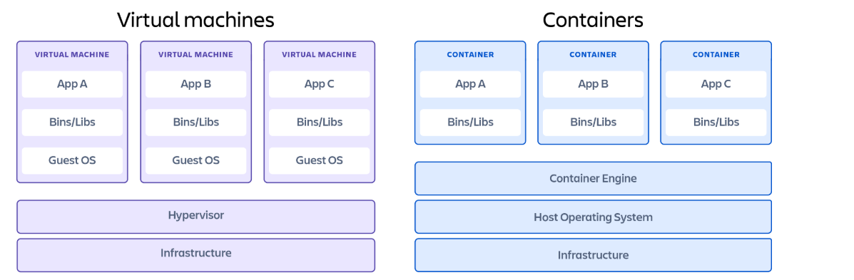

Azure Kubernetes Service
Manges the container orchestration

Azure Functions
Functions can be either stateless or stateful. When they're stateless (the default), they behave as if they restart every time they respond to an event. When they're stateful (called Durable Functions), a context is passed through the function to track prior activity.
• Use Power Automate when you want quick, user-friendly automation between services.
• Use Azure Functions when you need custom code, heavy logic, or better scalability.

Containers are used for complex logic, long time working in a webapp, legacy app migrations- lift ad shift etc while Azure functions are used when we need simple functions/tasks using API like webhook trigger etc. Power Automate can be used if there simpler tasks like emails sending, teams notifications, one drive/share point check for files etc. Azure functions can be used to read the context of file.

Types of Azure App Services
WebApp – To build any web applications using nodejs, python, php etc
ApiApp – To build any REST api apps
WebJob – To do simpler web based automatic tasks like, send email or resize images once signedup/uploaded respectively
MobileApp – To build mobile apps and send notifications/store data in Azure SQL database

Azure Virtual Networking
Azure VNet and subnet are to securely communicate my own azure resources with on-premise servers/consumers on internet/with each other resources eg: my database talks to my webapp.
It has both public and private endpoints to connect and communicate with.
Simple Analogy:
Imagine:
- You have a private neighborhood (that's your VNet)
- Inside it, you have houses (your virtual machines, databases, web apps, etc.)
- These houses can talk to each other through streets (called subnets)
- You can also build a gate to allow some trusted visitors (like the internet or another network)
Communicate with on-premises resources – 3 types:
Point to Site: Client computer creating a VPN connection to talk to Azure virtual network and then to its resources.
Site to Site: Connecting the whole on-premise network through VPN Device to azure network. Hence, all the azure resources will be displayed as part of on-premise. They are all now connected through internet.
ExpressRoute: Connecting on-premise with Azure, without internet but through high speed and secured fiber optic
Border Gateway Protocol (BGP):
Imagine Azure and your office are two cities connected by roads.
BGP is the GPS system that helps the two cities keep track of which roads are open and what’s the best way to send cars (data).
Connect virtual networks: Connect two virtual networks not through internet but through Microsoft network hence 2 virtual networks in two different regions can be connected – global interconnect

Azure virtual private networks
VPN creates an encrypted tunnel when data is transferred from one resource to another using public network
Policy based VPN – You will predefine the IP addresses. So if the packet is designed to send to one of the predefined IP, then, the tunnel mentioned in the IP will be used to send the data securely
Analogy:
- The "policy" is a predefined rule like:
"All data from IP address A must go through Tunnel 1."
- Every time a packet arrives, the gateway checks the source and destination IP.
- It then uses the rule to decide which VPN tunnel to use.
Route based VPN: It creates the tunnel and sends packets in a shared public internet but in a secured wa. BGP says which path to choose and Route based VPN creates the tunnel and sends the packets

Difference between Route based VPN, BGP, ExpressRoute
Route-Based VPN = Encrypted Tunnel Over the Internet
- It’s like building a secure tunnel through the public internet.
- Think of it like driving on public highways in a bulletproof car.
- You control where traffic goes using a routing table.
- It’s flexible and easy to set up.
- Traffic is encrypted but still goes over the shared public internet.
Example: You use a route-based VPN to securely connect your office to Azure so employees can access a cloud database.

🚄 2. ExpressRoute = Private, High-Speed, Dedicated Line
- This is like building your own private train track directly from your office to Azure.
- It does not go through the internet—it's faster, more secure, and more reliable.
- Great for banks, hospitals, or large companies with heavy or sensitive traffic.
- More expensive and requires setup with a network provider.
Example: A bank uses ExpressRoute to transfer customer data to Azure securely and at high speed without touching the public internet.

🧭 3. BGP (Border Gateway Protocol) = Smart GPS for Routing
- BGP is not a connection, it’s the navigation system that tells your data which route to take—whether you're using VPN or ExpressRoute.
- It automatically updates and shares route info between your office and Azure.
- Helps Azure and your network find the best path for traffic.
- Often used together with Route-Based VPN or ExpressRoute.
Example: Your company has two VPNs and one ExpressRoute connection. BGP helps Azure pick the best route based on availability and performance.

Azure VPNs – High availability scenarios
Active/Active: Both tunnels will be active for the IP address, BGP is used to smartly regulate the network traffic.
Active/Standby: BGP is not used. One tunnel will be active while the other is in watch/standby mode. If one goes down, other tunnel will restore.
ExpressRoute Failover: If there is any physical disruption to the optic cables, there should be a secondary VPN network connection that backups ExpressRoute tasks

ExpressRoute Global Reach

• Your Asia office is connected to Azure via ExpressRoute Circuit A.
• Your Europe datacenter is connected to Azure via ExpressRoute Circuit B.
• You enable Global Reach to link Circuit A and Circuit B.
• Now, Asia ↔ Europe traffic flows privately across Microsoft’s network — no internet involved.

ExpressRoute connectivity models

Direct ExpressRoute – Uses Microsoft cable network directly
Colocation – Shares the same location where Azure datacentre is located and then connect via cable
Point to Point – Connection between azure and the office through cable
Any to Any –Azure is connected to office through WAN so it act as one of the office branches and all the branches and azure talks to each other as azure is one of them

Azure storage services
LRS – Durability – 11 nines – 99.remaining 9 nines - (99.999999999%) – 3 copies in one zone(one or more datacentre)
ZRS – 12 nines of durability – each copy in three different zones.
GRS – 16 nines – primary LRS pairs with secondary LRS in other region
GZRS – 16 nines – primary - ZRS pairs with secondary - LRS in other region
RPO stands for Recovery Point Objective
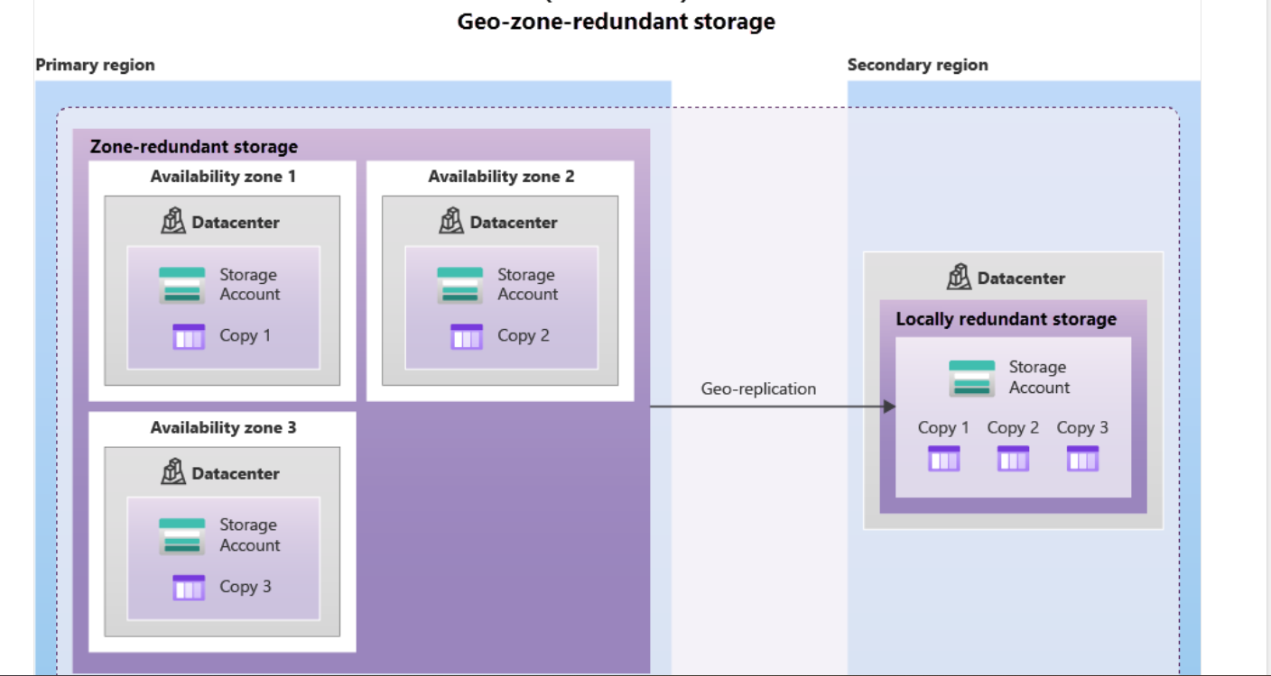

By default, data in secondary region cannot have read access until the primary shuts down or you manually enables that option. If you enables it, even if primary works fine, you can still read the data in secondary region.

- Azure Blobs: A massively scalable object store for text and binary data. Also includes support for big data analytics through Data Lake Storage Gen2.
- Azure Files: Managed file shares for cloud or on-premises deployments.
- Azure Queues: A messaging store for reliable messaging between application components.
- Azure Disks: Block-level storage volumes for Azure VMs.
- Azure Tables: NoSQL table option for structured, non-relational data.

